Paper Title (use style: paper title)
First Author
(Affiliation): department, name of organization
City, Country
e-mail address
Second Author
(Affiliation): department,. name of organization
City, Country
e-mail address

Abstract—This electronic document is an example. The various components of your paper [title, text, heads, etc.] are already defined on the style sheet, as illustrated by the portions given in this document. (Abstract – 250 words or less)
Keywords - component; formatting; style; styling; insert (key words)

Introduction (Heading 1)
This template provides authors with most of the formatting specifications needed for preparing electronic versions of their papers. All standard paper components have been specified for three reasons: (1) ease of use when formatting individual papers, (2) automatic compliance to electronic requirements that facilitate the concurrent or later production of electronic products, and (3) conformity of style throughout the conference proceedings. Margins, column widths, line spacing, and type styles are built-in; examples of the type styles are provided throughout this document and are identified in italic type, within parentheses, following the example.
Use Times New Roman font thought the paper. The length of final submission is six (6) pages maximum. Margins – top 2.54 cm, bottom 2.54 cm, left 2.54 cm, right 2.54 cm. Final formatting will be done by the Springer Editing Team to conform to printing specifications.

2.0 Prepare Your Paper Before Styling
Before you begin to format your paper, first write and save the content as a separate text file. Keep your text and graphic files separate until after the text has been formatted and styled. Do not use hard tabs, and limit use of hard returns to only one return at the end of a paragraph. Do not add any kind of pagination anywhere in the paper. Do not number text heads-the template will do that for you.
Finally, complete content and organizational editing before formatting. Please take note of the following items when proofreading spelling and grammar:

Abbreviations and Acronyms (Heading 2)
Define abbreviations and acronyms the first time they are used in the text, even after they have been defined in the abstract. Abbreviations such as IEEE, SI, MKS, CGS, sc, dc, and rms do not have to be defined. Do not use abbreviations in the title or heads unless they are unavoidable.

Equations
The equations are an exception to the prescribed specifications of this template. You will need to determine whether or not your equation should be typed using either the Times New Roman or the Symbol font (please no other font). To create multileveled equations, it may be necessary to treat the equation as a graphic and insert it into the text after your paper is styled.

Using the Template
After the text edit has been completed, the paper is ready for the template. Duplicate the template file by using the Save As command, and use the naming convention prescribed by your conference for the name of your paper. In this newly created file, highlight all of the contents and import your prepared text file. You are now ready to style your paper; use the scroll down window on the left of the MS Word Formatting toolbar.

3.1 Identify the Headings
Headings, or heads, are organizational devices that guide the reader through your paper. There are two types: component heads and text heads.
Component heads identify the different components of your paper and are not topically subordinate to each other. Examples include Acknowledgments and References and, for these, the correct style to use is “Heading 5”. Use “figure caption” for your Figure captions, and “table head” for your table title. Run-in heads, such as “Abstract”, will require you to apply a style (in this case, italic) in addition to the style provided by the drop down menu to differentiate the head from the text.
Text heads organize the topics on a relational, hierarchical basis. For example, the paper title is the primary text head because all subsequent material relates and elaborates on this one topic. If there are two or more sub-topics, the next level head (uppercase Roman numerals) should be used and, conversely, if there are not at least two sub-topics, then no subheads should be introduced. Styles named “Heading 1”, “Heading 2”, “Heading 3”, and “Heading 4” are prescribed.

Figures and Tables

3.2.1 Positioning Figures and Tables(Heading 3): Insert figures and tables after they are cited in the text. Figure captions should be below the figures; table heads should appear above the tables.
Table 1: Table Type Styles
Table Head | Table Column Head
 | Table column subhead | Subhead | Subhead

copy | More table copy

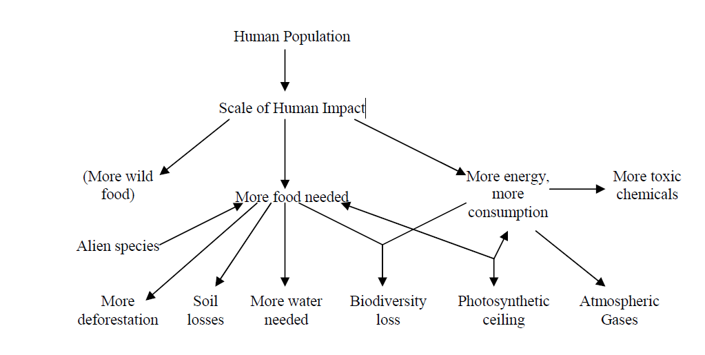
FIGURE 1: Example of a Figure Caption. (figure caption)
Figure Labels: Use 10 point Times New Roman for Figure labels. Use words rather than symbols or abbreviations when writing Figure axis labels to avoid confusing the reader.

Acknowledgment (Heading 5)
The preferred spelling of the word “acknowledgment” in America is without an “e” after the “g”. Avoid the stilted expression, “One of us (R. B. G.) thanks . . .” Instead, try “R. B. G. thanks”. Put sponsor acknowledgments in the unnum-bered footnote on the first page.

References
The template will number citations consecutively within brackets [1]. The sentence punctuation follows the bracket [2]. Refer simply to the reference number, as in [3]—do not use “Ref. [3]” or “reference [3]” except at the beginning of a sentence: “Reference [3] was the first . . .”
Number footnotes separately in superscripts. Place the actual footnote at the bottom of the column in which it was cited. Do not put footnotes in the reference list. Use letters for table footnotes.
Unless there are six authors or more give all authors' names; do not use “et al.”. Papers that have not been published, even if they have been submitted for publication, should be cited as “unpublished” [4]. Papers that have been accepted for publication should be cited as “in press” [5]. Capitalize only the first word in a paper title, except for proper nouns and element symbols.
For papers published in translation journals, please give the English citation first, followed by the original foreign-language citation [6].

- G. Eason, B. Noble, and I. N. Sneddon, “On certain integrals of Lipschitz-Hankel type involving products of Bessel functions,” Phil. Trans. Roy. Soc. London, vol. A247, pp. 529–551, April 1955. (references)
- J. Clerk Maxwell, A Treatise on Electricity and Magnetism, 3rd ed., vol. 2. Oxford: Clarendon, 1892, pp.68–73.
- I. S. Jacobs and C. P. Bean, “Fine particles, thin films and exchange anisotropy,” in Magnetism, vol. III, G. T. Rado and H. Suhl, Eds. New York: Academic, 1963, pp. 271–350.
- K. Elissa, “Title of paper if known,” unpublished.
- R. Nicole, “Title of paper with only first word capitalized,” J. Name Stand. Abbrev., in press.
- Y. Yorozu, M. Hirano, K. Oka, and Y. Tagawa, “Electron spectroscopy studies on magneto-optical media and plastic substrate interface,” IEEE Transl. J. Magn. Japan, vol. 2, pp. 740–741, August 1987 [Digests 9th Annual Conf. Magnetics Japan, p. 301, 1982].
- M. Young, The Technical Writer's Handbook. Mill Valley, CA: University Science, 1989.

